iRobotsTheBomb Inc.
Your agile team is to create an on-line pamphlet for iRobotsTheBomb Inc. The company sells robots that can detect and dispose of explosive devices.

Your agile team must use inheritance, composition, exception handlers, a virtual function, and at least two overloaded operators. At least one class should use templates. At least one class must contain a pointer (a copy constructor needs to be written and tested). Highlight the above.

Design a very readable, easy to use interface to demonstrate your agile team’s program. Contingency handling should include addressing invalid input. Please let me know who your partner will be by October 26th (two points will be deducted from your score if you do not meet this deadline). All projects are due by December 5th. No late projects will be accepted. Your team must demonstrate your project before it will be graded. Each teammate must identify their accomplishments on the project.

Submit a UML class diagram, at least three use cases, and a state diagram with your project.

The assignment will be graded using the following scale:
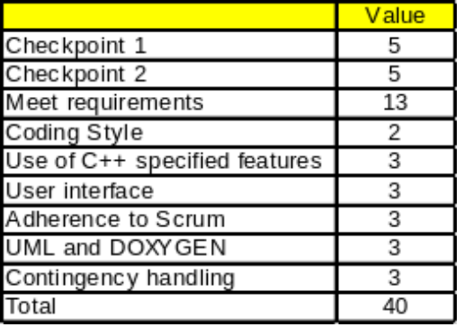
Schedule:
First checkpoint – November 7th – 5 points
Second checkpoint – November 21th – 5 points
Final checkpoint – December 5th – 30 points

The iRobotsTheBomb on-line pamphlet must:
- Provide a help option to explain how to operate your program
- Contain a sales pitch that includes key selling points – keeping the target market in mind.
- Identify a list of physical environments that are supported
- Provide a one paragraph – concept of operations (what does it do and how it does it)
- Provide an least three options along with a corresponding price for each option
- Provide a logistics or maintenance plan with pricing
- Provide a guarantee policy
- Provide satisfied customer testimonials (solicit for additional testimonials). The testimonials should be persistent between executions.
- Provide “contact us” methods
- Your program should read from a customer file that keeps track of which companies have already received the pamphlet. There is a corresponding customer rating (very interested, somewhat interested, not interested, never call again). Some customers are considered key while other customers are considered “nice to have”. Customer names must be unique.
- Your program should be able to update the customer list (change customer rating, the “key” field, address, etc.) – administrator only
- Your program should be able to add and delete customers. – administrator only
- A perspective customer can request a copy of the pamphlet.
- The customer list should be persistent between executions.
- A customer should have the ability to order one or more iRobot devices.
- Customers should not have the ability to view/print the customer list – administrator only function
- After a pamphlet is sent to a perspective customer, the customer list should reflect the fact that the pamphlet was sent.
- Produce a customer listing sorted by customer name (at any time) - administrator only
- Produce a customer listing sorted by customer name (at any time) containing only the “key” customers. – administrator only

Use the following data:
Los Angeles Airport
1 World Way
Los Angeles, CA 90045
very interested
key

FBI
1234 Lincoln Ave.
Washington D.C. 00234
somewhat interested
key

CIA
987 Jefferson Blvd
Baltimore, MD 00754
not interested
key

Saddleback College
28000 Marguerite Pkwy
Mission Viejo, CA 92692
somewhat interested
nice to have

Los Angeles Dodgers
1000 Elysian Park Avenue
Los Angeles, CA 9 0012
very interested
nice to have

Los Angeles Angels
2000 East Gene Autry Way
Anaheim, CA 92806
very interested
key

